**Assignment 1:**

**Section 0:**

1. Create a directory “project_dir” and cd to “project_dir”:

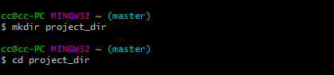

2) Initialize git version database. (git init):



3) Create a new file index.html:



4) Check the git status. You should find index.html as untracked file:

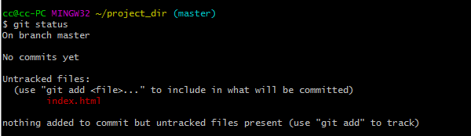

5) Stage the index.html file:



6) commit index.html:

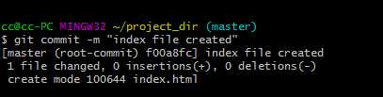

7) Make few changes in index.html and create a new file info.txt:



8) Check git status. You should find index.tml and info.txt as untracked file:

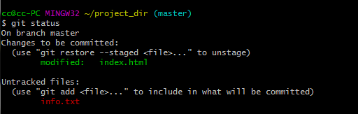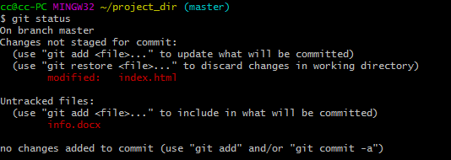

9) Configure git to ignore all txt files:



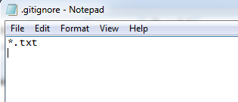

10) Again check the git status. You should find only index.html as untracked files:

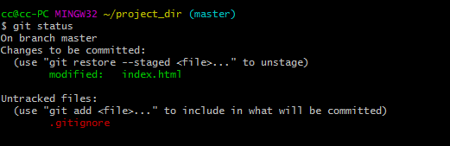

11) Stage and commit index.html:

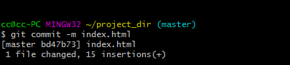

12) Log all your comments so far:

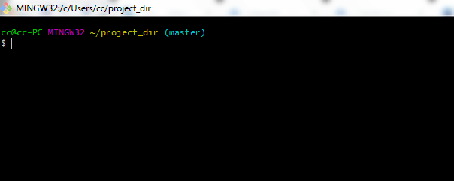

13) Make some changes in index.html

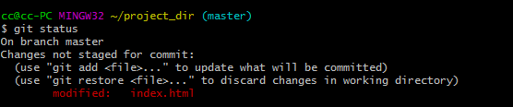

14) Revert the changes in the previous step using git command:

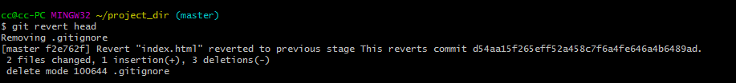

15) Again change index.html

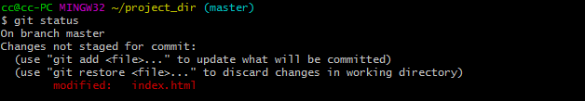

16) Stage index.html



17) Revert back the last stage:

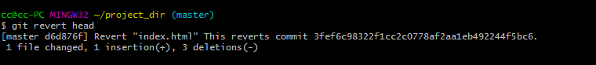

18) Rename “add” command to “my-add”



19) Using my-add command stage index.html again and commit changes



20) Revert last commit:

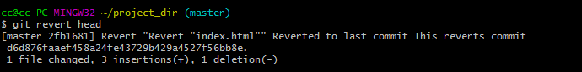

**Section 1:**

1. Create an empty directory “Assignments” and cd to “Assignments” :

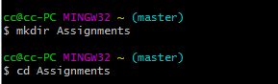

1. Create a file README.txt inside “Assignments” & write few lines about contents of “Assignments “ folder:

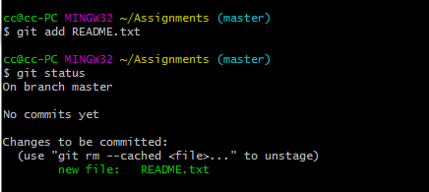

1. Commit README.txt

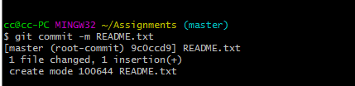

1. Now create a new branch “html-assignments”:



1. Switch to “html-assignments” branch:

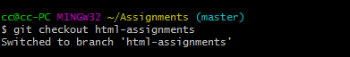

1. Copy all HTML assignments inside “html-assignments”:

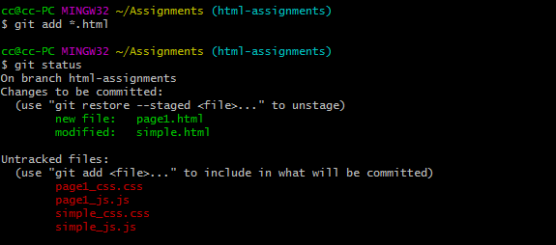

1. Commit HTML assignments into “html-assignments”:

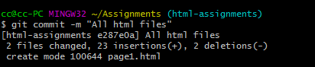

1. Make minor changes into few files belonging to “html-assignments” branch:

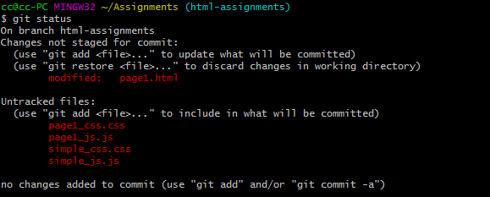

1. Commit those changed files:

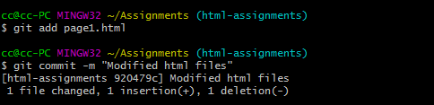

1. Switch to master branch:



1. Make minor changes into README.txt files and commit those changes into master:

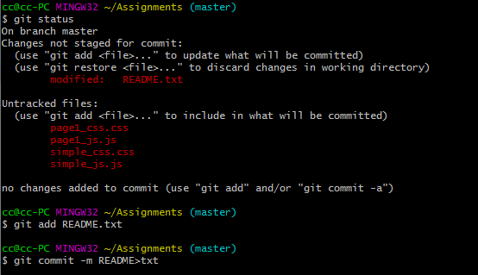

1. Again switch to “html-assignments”:



1. Make minor changes to few files belonging to “html-assignments” branch:

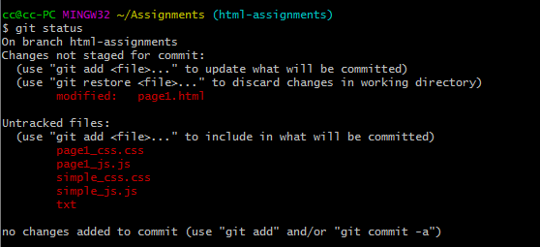

1. Commit those changes:

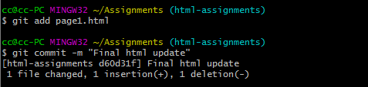

1. Switch to master:

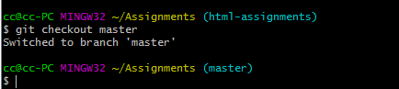

1. Merge “html-assignments” branch into master. Confirm all html assignments in master:

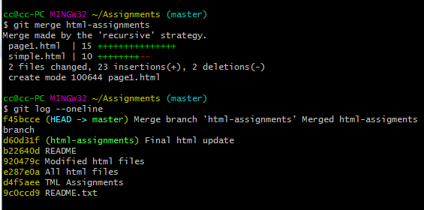

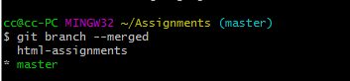

1. Finally delete the “html-assignments” branch:

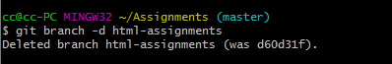

**Section 2: CSS Assignments**

1. Create a new branch “css-assignments”:



1. Switch to “css-assignments” branch:

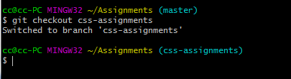

1. Copy all CSS assignments inside “Assignments” folder:
2. Commit CSS assignments into “css-assignments” branch:

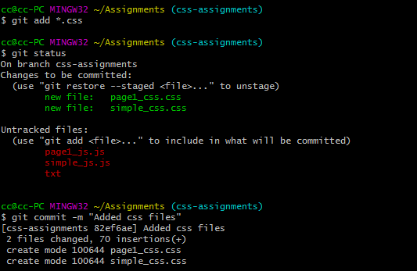

1. Make minor changes into README.txt file on line 1 belonging to css-assignments branch:

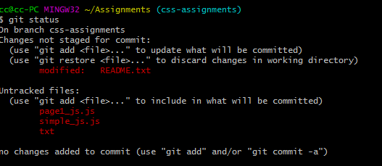

1. Commit those changed files:

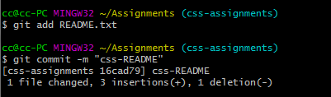

1. Switch to master branch:

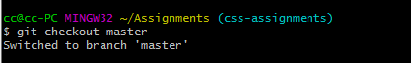

1. Make minor changes into README.txt files on line 1 and commit those changes into master:

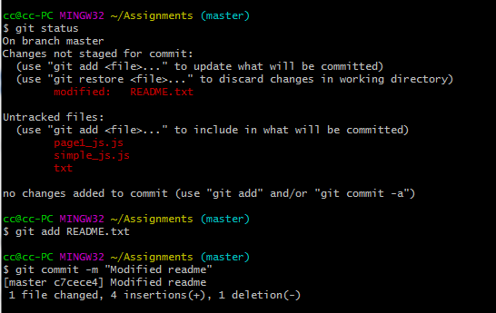

1. Again switch to css-assignments branch:

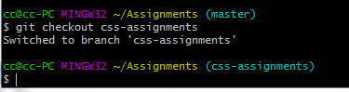

1. Make minor changes into few files belonging to css-assignments branch”:

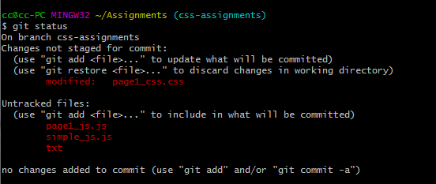

1. Commit those changes:

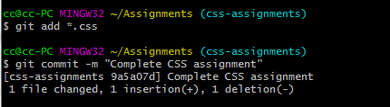

1. Switch to master:

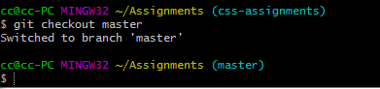

1. Merge css-assignments branch into master. Confirm all css assignments are shown in master:

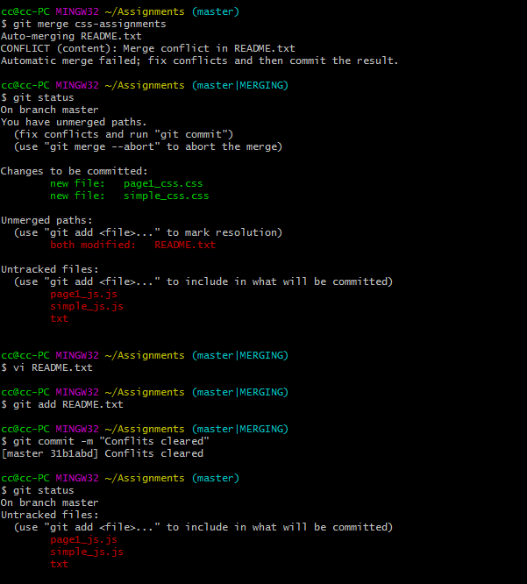

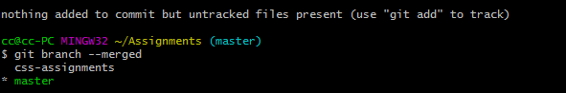

1. Finally delete css-assignments:

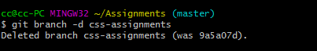

**Section 3: JavaScript Assignments:**

1. Create a new branch “js-assignments”:



1. Switch to “js-assignments” branch

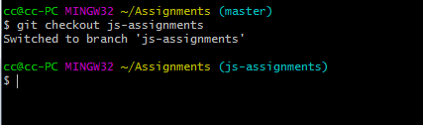

1. Copy all JS assignments inside “Assignments” folder:

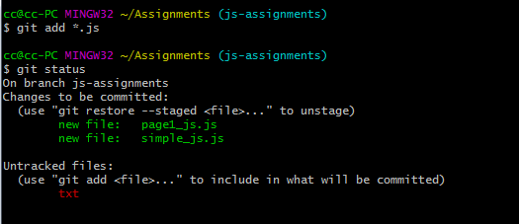

1. Commit JS assignments into “js-assignments” branch:

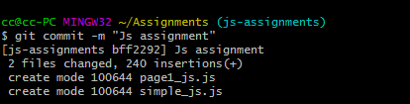

1. Make minor changes into README.txt file on line 1 belonging to js-assignments branch:

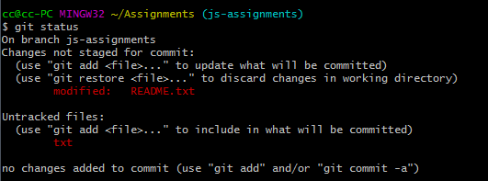

1. Commit those changed files

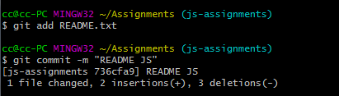

1. Switch to master branch

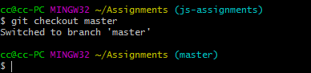

1. Make minor changes into README.txt files on line 1 and commit those changes into master:

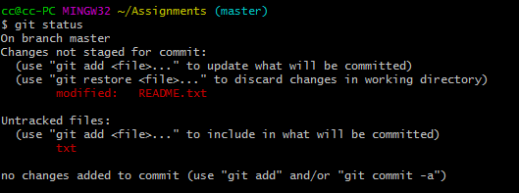

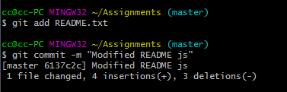

1. Again switch to js-assignments branch:

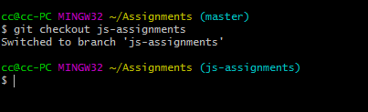

1. Make minor changes into few files belonging to js-assignments branch”:

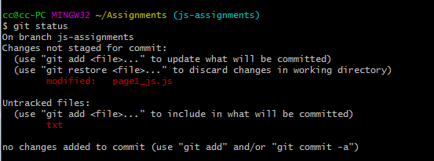

1. Commit those changes:

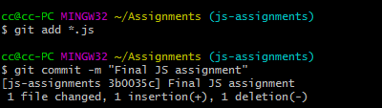

1. Switch to master:

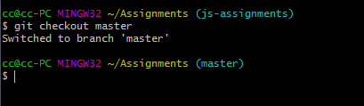

1. Merge js-assignments branch into master. Confirm all js assignments are shown in master:

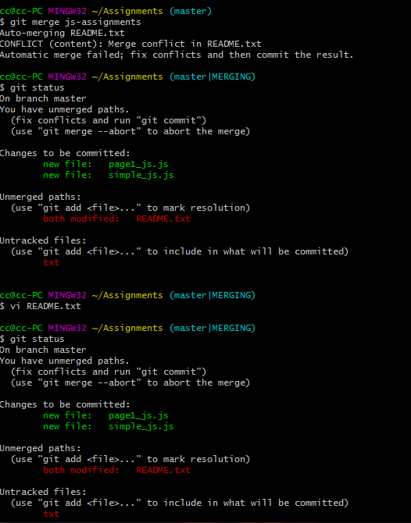

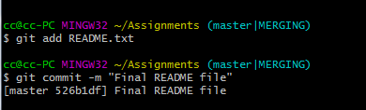

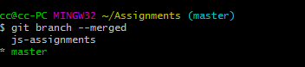

1. Finally delete js-assignments:

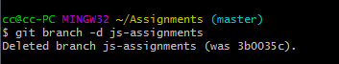

**Section 4: Pushing assignments to remote repository:**

1. Create a github account if you do not have already:
2. Login into that account:
3. Create new public repository “Freshersbranc-july20”:
4. Commit and push any sample file to this repository:

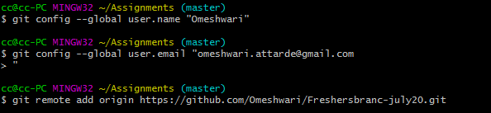

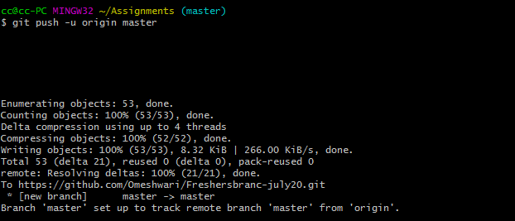

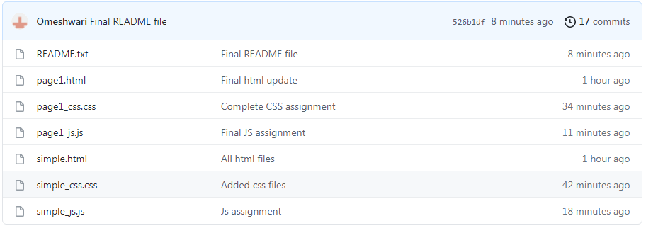

**Section 5: Pushing source code to remote repository using eclipse GIT plug-in:**

1. One developer from the project team will create a eclipse project sample-project and add sample code files. Then commit all files through eclipse GIT plugin:
2. Collaborate other team members with your github account so that they can also modify te committed files:
3. Other developers from same team will checkout all files from remote repository. This might get conflicts since certain files fail to merge. In such case, merge it manually:
4. Commit and push the sample-project project: